Special Olympics Ohio

Snowboarding Rules Manual (rev. 12/2022)

The Official Special Olympics Sports Rules for Snowboarding shall govern all Special Olympics competitions. As an international sports program, Special Olympics has created these rules based upon International Ski Federation (FIS) rules for snowboarding found at http://www.fis-ski.com/. FIS or National Governing Body (NGB) rules shall be employed except when they are in conflict with the Official Special Olympics Sports Rules for Snowboarding. In such cases, the Official Special Olympics Sports Rules for Snowboarding shall apply.

Official Events
The SOOH Snowboarding season runs October through February. The State Tournament is held during the first quarter of each year. To qualify for the State Snowboarding Competition athletes must be in a training program for at least 8 weeks prior to the State Competition.
Special Olympics Ohio provides a range of events to offer athletes of varying abilities the opportunity to compete. The following is a list of official events available in Special Olympics Ohio. Each of the following events are also offered as a Unified event.
- Novice Glide
- Novice Super Glide
- Intermediate Giant Slalom
- Intermediate Slalom
- Advanced Giant Slalom
- Advanced Slalom

Facilities
Slopes
- Slopes must be suitable in length, width, and difficulty to accommodate snowboarders’ abilities. All race and training venues must be safe.
Lifts
- Whenever possible, lifts will be available either on or directly adjacent to the race and training venues
Finish Area
- The finish area for all snowboarding races shall allow enough room for a competitor to safely come to a stop.
- Whenever possible, all finish areas shall be fenced to keep spectators off the venue.
Ski Area
- The ski area shall make available their ski patrol to oversee all medical needs and procedures for the events.
- In the case of medical volunteer participation, the ski area must be informed well in advance of the event so they may coordinate the medical procedures. At most ski locations, this is defined as the responsibility of the ski area.
Warming Facilities
- Warming facilities should be readily available from the slopes and parking lot.
- The facilities should be large enough to accommodate the Special Olympics group in case of inclement weather.
- Volunteer registration should be conducted inside.
- Awards ceremonies should be conducted inside only in case of bad weather.
Ski Area Parking
- A ski area parking lot should allow for enough parking spaces for event volunteers, Special Olympics staff, coaches and competitors.
- Adequate parking for individuals with physical disabilities should be available for attendees.
- Emergency vehicle access is mandatory.
Ancillary Facilities
- Room for snowboard storage
- Room for snowboard preparation
- Room to store Special Olympics equipment
- Snowboard rentals
- Room for coaches’ meeting
- Covered facilities for:
  - Jury Meeting
  - Event Timing and Calculations
  - Start Area

Equipment
Helmets
- All competitors and forerunners must wear a crash helmet for official training as well as for the race that meets the FIS Equipment Specifications. Soft ear protection is only permitted for helmets used in Slalom. All helmets must carry an approved tag. Competitors without an approved tag will not be allowed to start. (FIS rule 707) See Appendix A for more information.
Attire/Uniforms
- Competitors are required to wear appropriate snowboard attire (snowboarding or skiing pants, jacket, gloves, etc.). The start official has discretion to prevent a competitor from starting until the appropriate correction(s) have been made.
- A competitor must use the same attire and equipment for divisioning and finals. Changes in attire (from a jacket to a speed suit for example), or in equipment (from a freestyle board to a race board), will result in disqualification.
Ski Area
- The ski area shall provide ski patrol to oversee all medical needs and procedures for the events. In the case of medical volunteer participation, the ski area will coordinate the medical procedures.
Ski Area Maintenance Tools
- The ski area shall provide adequate snow grooming and venue preparation tools for all events.
- For deteriorating snow conditions course maintenance tools (rakes, shovels, and chemicals to harden snow) will be used and are the responsibility of ski area.
Gates and Poles
- Slalom and Giant Slalom gates consist of two poles: one outside pole and one stubby turning pole.
- Triangular banners must be placed at the bottom of the gate at snow level. The short or turning side of the panel must be able to tear away from the pole with Velcro or other suitable fastening. For all events, panels shall be used.

Course Layout and Equipment
- An auger or crowbar shall be made available for the course setter to set poles into the snow.
- Adequate protection for the start and finish areas shall be provided. Fencing and/or pop fencing may be used.
- Whenever possible, for safety reasons, the courses should be fenced off to be perceived by the skiing public as a self-contained racing venue. Additional fencing, snow fencing, and protective bagging are the responsibility of the ski area.
- Start and finish banners shall be used.
- Whenever possible, electric timing equipment, with backup system, shall be used. When this is not possible, handheld timing may be used. Gate judges shall be responsible for timing for the one-minute rule.
- Race courses for Snowboarding shall be staged in different venues from Alpine Ski racing. When this is possible, gates for Snowboarding will be used instead of Alpine Giant Slalom gates or Downhill gates.
Public Address System
- The public address system should be available for:
  - Announcing competition staging and results.
  - Announcing the competition event.
Information Boards
- Start Order Board: Shall be located at the start and contain the snowboarders’ start order, bib number, and other pertinent information.
- Result Board: Shall be located outside the finish area to post results and list snowboarders’ by name, start order, and bib number.
- General Information Board: Shall be located in close proximity to the racing venues, awards area, and lodge; and shall contain general information and announcements.
Snowboard Equipment Repair Tools
- Repair tools shall be used by certified equipment personnel during race situations.
Communications Systems
- A communications system, connecting race venues, medical personnel, volunteer coordinators, and event officials, shall be in place. Race venues may have additional communication.

Race Staff Identification
- At times it is helpful and imperative to identify race and event officials. Host organizations may want to provide arm bands, windbreakers, or hats.

Rules of Competition
General Rules and Modifications
- FIS rules offer Special Olympics athletes and competition directors the benefits of standardized snowboard competitions worldwide. It must be remembered that FIS rules were written to govern competitions for high ability athletes only. A small percentage of Special Olympics snowboard athletes have acquired such a high level of skill. Therefore, it is essential to assess all Special Olympics athletes on snowboard courses which meet their abilities. FIS regulations for Snowboarding (number of gates, vertical gate combinations and vertical drop) require courses on terrain which in most cases are too steep and long for sliders of lower abilities. Special Olympics snowboard courses have been modified from the FIS rules to accommodate our athletes. The rules for setting courses, that is, number of gates, distance from turning pole to turning pole, start and finish area requirements, remain largely the same as FIS rules. Specific snowboard modifications shall replace FIS requirements as stated in the Official Special Olympics Winter Sports Rules.
Divisioning
- Novice, Intermediate and Advanced competitors shall have two runs on a modified Giant Slalom course of their ability level, with the fastest time used to determine their division for competition. If time in the race organizers schedule permits, divisioning time trials may be conducted for Slalom and Giant Slalom. In the first run of competition in each division, the fastest divisioning time starts first, slowest last.
Start Areas
- All start areas shall be flat, enabling the competitors to stand in the start in either a relaxed or ready position.
- Care should be given to provide easy access to this area as well as securing the area from the flow of general public skier traffic.

Advancement
- During competition, if the competitor moves out of the general direction of the line of the course (falls or misses a gate, etc.) he/she shall have one minute from the time of the deviation to re-enter the course.
- A competitor who fails to adhere to this one-minute time limit, or receives assistance of any kind, shall be disqualified. Disqualification shall be determined on the gate card by the Gate Judge assigned to the gate closest to where the infraction occurred. The Gate Judge is responsible for timing the one minute.
Start Command
- For all Special Olympics alpine events at each ability level, the start command shall be as follows: "Five. Four. Three. Two. One. GO!"
- The timer begins when the competitor’s front boot crosses the start line, or when the electric timing wand is activated.
Gate Line
- The gate line is determined by the turning pole.
Correct Passage
- A gate has been passed correctly when the competitor's snowboard tip and both feet have passed across the gate line. The start and finish lines are the same as a gate line.
- In the event that a competitor removes a pole from its vertical position before both the competitors’ snowboard tips and both feet have passed the gate line, the snowboard tip and feet must pass the original gate line.
Event Modifications
- All events – course inspection.
  - At the jury’s discretion, a timed course inspection period may be replaced by having an official forerunner, lead a line of competitors at very slow speed through the course one time.
- Slalom/Giant Slalom
  - Slalom and Giant Slalom races will consist of two timed runs. The combined times for each discipline will determine the results for awards.
  - A course reset for the second run will be determined by the Jury.
  - In Slalom and Giant Slalom events, the competitor’s first run times shall determine his/her second run start order within the division. Slowest first run time will start first, fastest last. Disqualified competitors may have a second run, but they will run at the end of their division.
- Unified Events
  - Unified Slalom and Giant Slalom
    - Partner Events
    - Teams must consist of one partner and one athlete
    - For Divisioning, each competitor will make two runs with the best of the two used to create divisions.
    - The final score will be the combined total of both runs for the partner and the athlete.

Levels of Competition
Novice Snowboarding Events
- Glide
  - Diagram
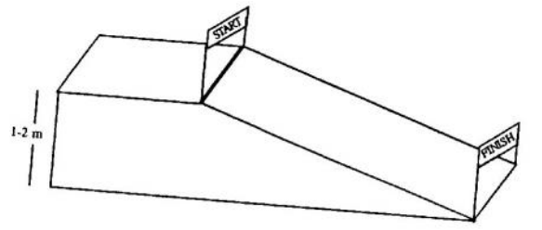

  - Set-up Terrain (Beginner Terrain close to base lodge)
    - The terrain shall be one to two vertical meters.
    - The terrain shall be 10 to 15 meters in length.
    - The slope is constant with the finish in a flat area.
    - Set up a flat start area with the start line at the point where flat goes to glide terrain.
    - Set the start gate one meter wide with the start line between the two poles.
    - Set the finish gate four meters wide with the finish line between two poles. Use a finish banner whenever possible.
  - Race Procedure
    - Competitors stand buckled into both bindings with the front boot directly over the start line. The Competitor may receive assistance from the start referee to hold their balance and/or position.
    - On the start command "Five. Four. Three. Two. One. GO!" the competitor leaves the start area. If the competitor is having trouble starting, the start referee may assist in the forward momentum of the competitor.
    - The timer starts when the competitor’s front boot crosses the start line.
    - The competitor glides from the start to the finish.
    - The timer stops when the competitor’s front boot crosses the finish line.
- Super Glide
  - Diagram
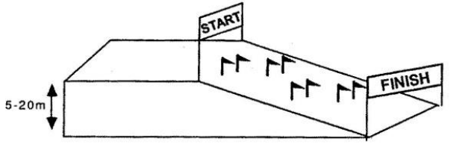

  - Set-up Terrain (Beginner Terrain close to the base lodge)
    - The terrain shall be five to 20 vertical meters.
    - Course width: 25 meters minimum.
    - Course length: 50 to 100 meters.
    - Fall line terrain, constant pitch without fallaways or counter slopes.
    - Place three to six gates set rhythmically to allow for consistent gliding wedge turns the length of the course.
    - The start area shall be flat with the start line or timing wand set where flat area goes to slope. Start line is less than one meter wide.
    - The finish area is set at least four meters wide, entering competitors into a flat terrain area.

  - Race Procedures
    - Competitors stand buckled into both bindings with the front boot directly over the start line. The Competitor may receive assistance from the start referee to hold their balance and/or position.
    - Competitor leaves on start command "Five. Four. Three. Two. One. GO!"
    - When the front boot crosses the start line or the competitor’s leg activates the start wand, the timer starts.
    - The timer stops when the competitor’s front (first) boot crosses the finish line.
  - Skill Level
    - Competitor is able to perform sideslip and falling leaf and can maintain his or her balance on a moving snowboard while buckled in with both feet.

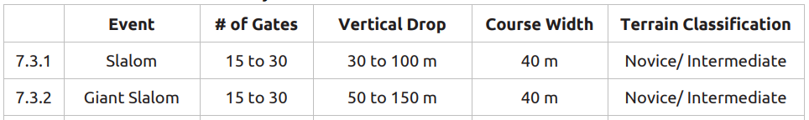
Intermediate Snowboard Course Layout

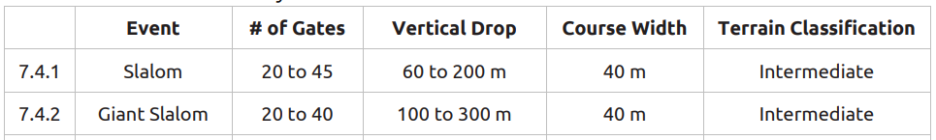
Advanced Snowboard Course Layout

APPENDIX A

