## Special Olympics Ohio

## Competitive Cheer Rules Manual (Rev. 12/2022)

The Official Special Olympics Sports Rules for Competitive Cheer shall govern all Special Olympics competitions. As an international sports program, Special Olympics has created these rules based upon the International Cheer Union (ICU) rules for Special Abilities cheerleading found at www.cheerunion.org. ICU rules shall be employed along with the following added Special Olympics guidelines: Team Size, Unified Sports®, Individual Skills Competition and Divisioning. In all cases, the Official Special Olympics Sports Rules Article 1 shall apply.

Special Olympics Ohio will follow the safety rules, as well as skill levels defined as Introductory, Beginner, Novice and Intermediate, as set forth by ICU. The ICU Rules and regulations have already instated modifications specifically for individuals with intellectual disabilities. Special Olympics has created additional provisions to compliment the ICU’s Special Abilities Rules. Coaches are responsible for following the safety rules and following the skills progression for athletes and Unified partners.

### Official Events

The SOOH Competitive Cheer season runs October through February. The State Tournament is held during the first quarter of each year.

Special Olympics Ohio provides a range of events to offer athletes of varying abilities the opportunity to compete. Coaches are responsible for providing training and event selection appropriate to each athlete’s skill and interest. Official score sheets can be found below in Appendix C & D. The following is a list of official events available in Special Olympics Ohio. Each team event is also available as a Unified event.

* Individual
* Team Non-Mount & Non-Tumble
* Team Not-Mount
* Team Non-Tumble
* Team Mount & Tumble

### Divisioning

The purpose of Divisioning is grouping Competitive Cheer athletes or teams by age, gender and ability giving everyone a reasonable chance to win. Refer to SOI Divisioning found at: <https://resources.specialolympics.org/sports-essentials/divisioning>

### Team Competition

The purpose of cheerleading is to entertain and motivate a crowd to cheer for a team.  These routines incorporate cheer, dance, stunts, and/or tumbling in a routine.

***Team Size***

Special Olympics Ohio recommended team sizes are as follows:

* Small: Minimum of four (4) and maximum of fifteen (15)
* Large: Minimum of sixteen (16) and maximum of twenty-four (24)

***Skill Levels (See Appendix A for further definitions of skill levels & Appendix B for routine guide)***

Introductory (Pre‐Level 0 | Non‐Build & Non‐Tumble)

* Routine
* Game Day
  + Sideline
  + Time Out
  + Fight Song
  + Cheer
  + Band Chant

Beginner (Level 0)

* Routine
* Game Day
  + Sideline
  + Time Out
  + Fight Song
  + Cheer
  + Band Chant

Novice (Level 1)

* Routine
* Game Day
  + Sideline
  + Time Out
  + Fight Song
  + Cheer
  + Band Chant

Intermediate (Level 2)

* Routine
* Game Day
  + Sideline
  + Time Out
  + Fight Song
  + Cheer
  + Band Chant

### UNIFIED SPORTS ® TEAM COMPETITION

Teams competing in this category should follow the Unified Sports Competitive Model. The ratio of athletes to Unified partners must be 1:1. In the event of an odd‐numbered team, there must be one less Unified partner than total number of athletes.

***Team Size***

Special Olympics Ohio recommended team sizes are as follows:

* Small: Minimum of four (4) and maximum of fifteen (15)
* Large: Minimum of sixteen (16) and maximum of twenty-four (24)

Special Olympics Unified partners should not perform any skills above the level of the Special Olympics athletes on the team.

***Skill Levels (See Appendix A for further definitions of skill levels & Appendix B for routine guide)***

Introductory (Pre‐Level 0 | Non‐Build & Non‐Tumble)

* Routine
* Game Day
  + Sideline
  + Time Out
  + Fight Song
  + Cheer
  + Band Chant

Beginner (Level 0)

* Routine
* Game Day
  + Sideline
  + Time Out
  + Fight Song
  + Cheer
  + Band Chant

Novice (Level 1)

* Routine
* Game Day
  + Sideline
  + Time Out
  + Fight Song
  + Cheer
  + Band Chant

Intermediate (Level 2)

* Routine
* Game Day
  + Sideline
  + Time Out
  + Fight Song
  + Cheer
  + Band Chant

### INDIVIDUAL SKILLS COMPETITION

The purpose of the individual skills competition is to allow athletes to train and compete in basic Cheer skills in the following categories:

* Introductory
* Beginner
* Novice
* Intermediate

The skills assessed are as follows:

* Motion
* Crowd Leading: Game Day – Sideline
  + Athlete performs a situational and repetitive chant with motions and simple skills to encourage the crowd.
* Incorporation
  + Use of poms, signs, or megaphones.
  + Use of skills as jumps, tumbling, motions, and dance.

Scoring will be based on team scoring fundamentals.

### NON-COMPETITIVE CHEER

A Local Special Olympics Program may choose to offer a non‐competitive cheer option, for Special Olympics Traditional and/or Unified Teams, which provides the opportunity for cheering and performing at Special Olympics competitions, special events, all sporting events, and community‐based events such as walks, races, high school games, etc. Providing non‐competitive cheer opportunities can help generate awareness and contribute to the growth of a Competitive Cheer program.

***Non-Competitive Cheerleading***

* All safety rules apply; team size & composition is open to the discretion of the team director within Special Olympics Guidelines. Team skill levels may range from the Introductory -Intermediate within accordance of the ICU Rules.

**Appendix A**

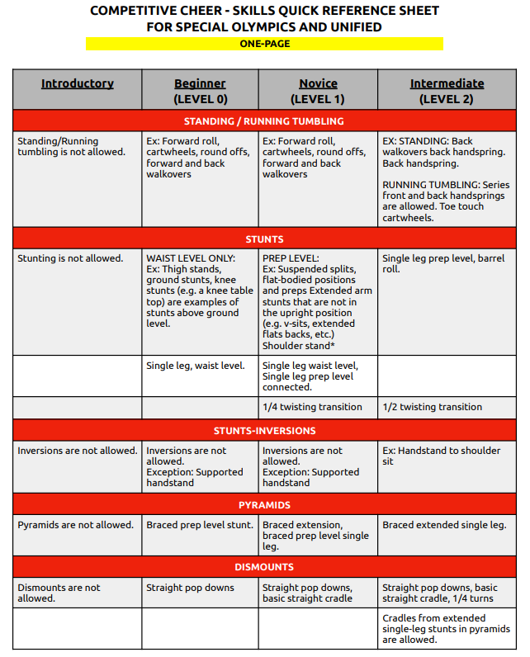

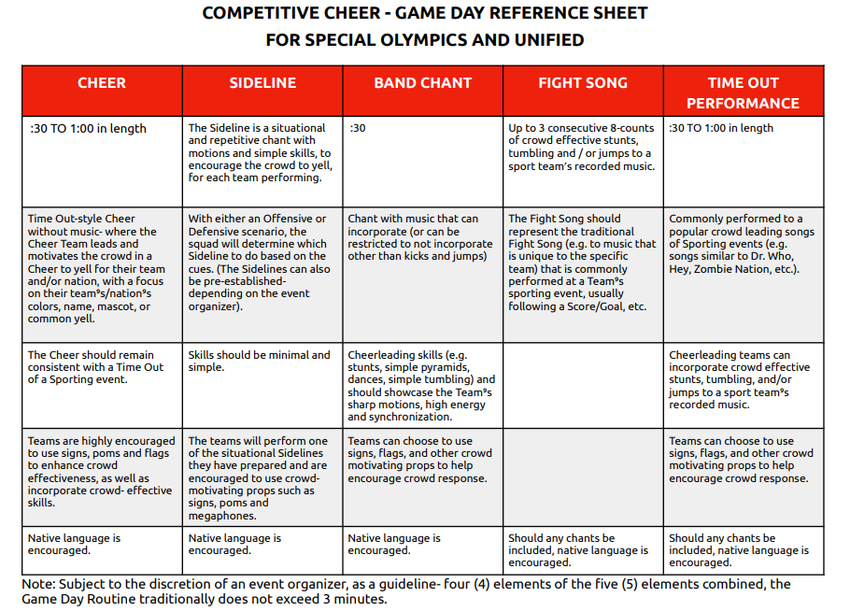**Appendix B**

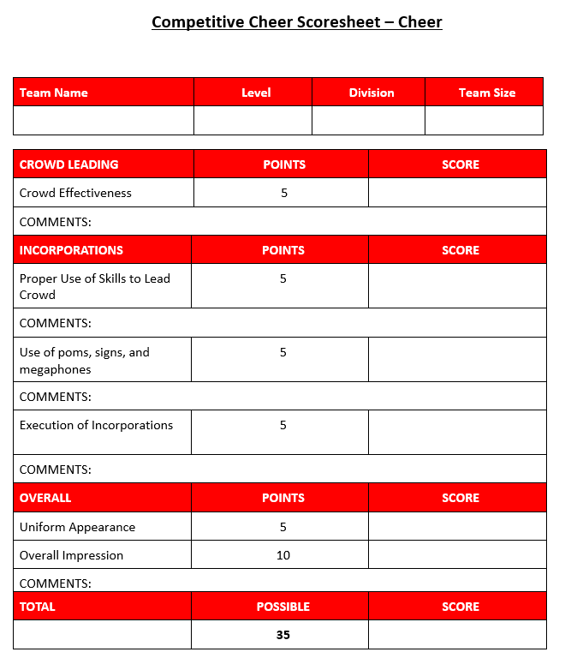**Appendix C**

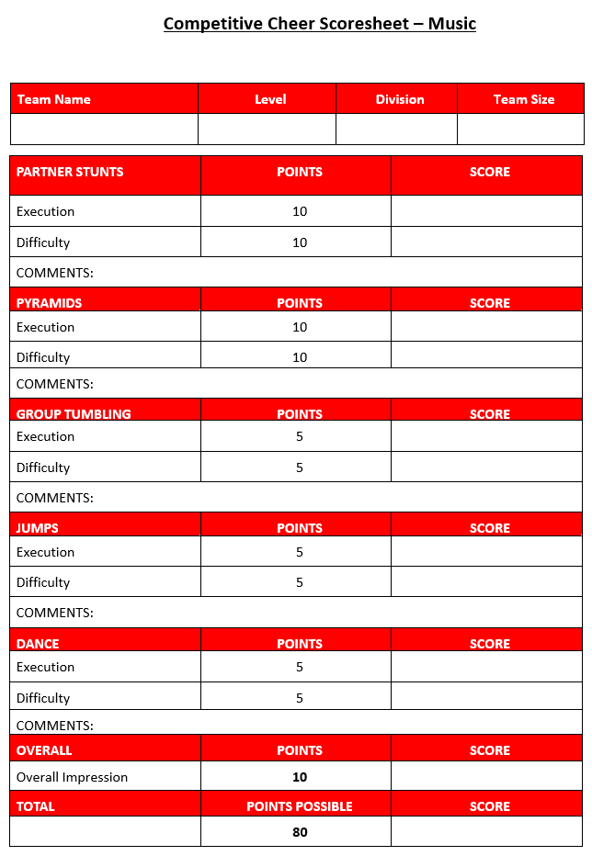

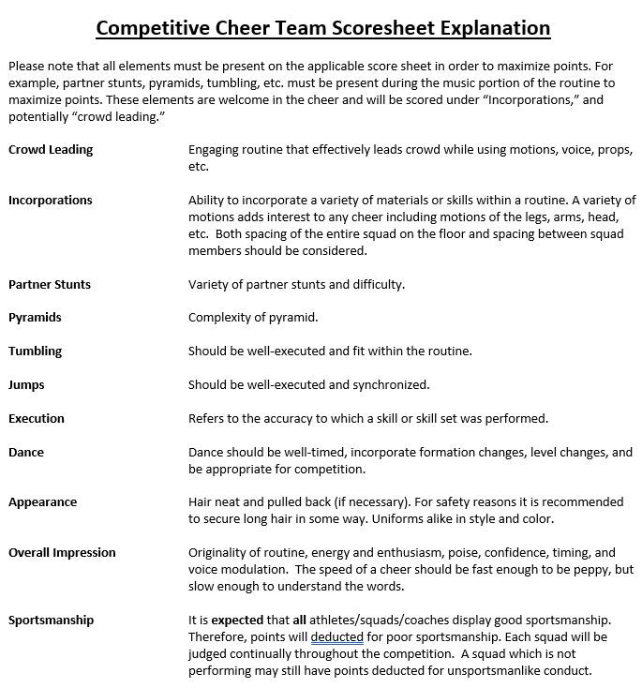

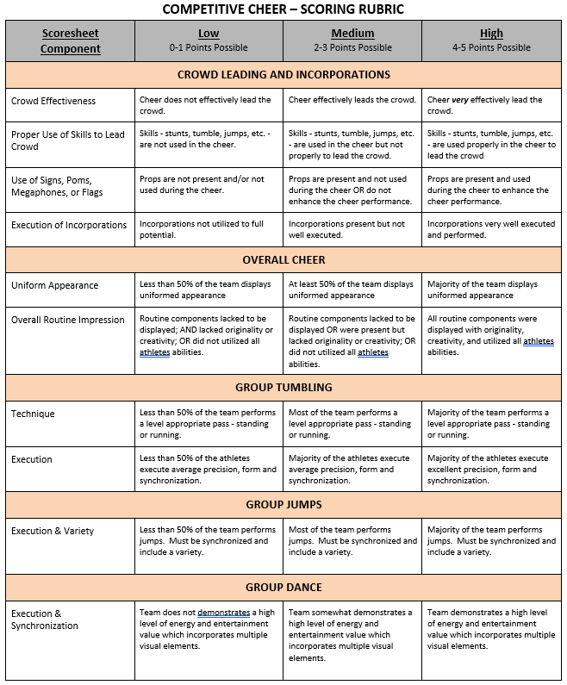**Appendix D**



